Whistleblowing

Policy ID Number: ORG010

Policy Passed by Trustees: October 2018

Review Date: October 2021

Policy Statements
  - The aim of this policy is to give clear guidelines/understanding to all RESTORE service users and staff, trustees, volunteers and students/trainees about RESTORE's whistle blowing policy.

  - The Public Interest Disclosure Act 1988 places a legal responsibility on everyone to ensure matters of serious public concern can be addressed.

  - RESTORE is committed to the highest possible standards of openness, probity and accountability. In line with this commitment RESTORE has drawn up this policy to ensure that employees with serious concerns about any aspect of the organisation's performance, management, standards or conduct should be able to voice those concerns.

  - The aims of this policy are threefold:-
- to encourage you to raise concerns about malpractice within the organisation without fear of reprisal;
- to reassure you that your concerns will be taken seriously;
- to provide information about how to raise your concerns and explain how RESTORE will respond

Scope of the Policy
  - This policy applies to all RESTORE employees, former employees, volunteers, trustees, agency staff and contractors engaged by RESTORE.

What is whistleblowing?
  - Whistleblowing is making a complaint on behalf of the organisation. In practical terms, whistleblowing occurs when a concern is raised about danger or illegality that affects others, e.g. clients, members of the public or the organisation itself. As the person blowing the whistle you would not usually be directly affected by the danger or illegality.

  - This is different from a complaint or grievance. If you make a complaint or lodge a grievance, you are saying that you personally have been poorly treated. This poor treatment could involve a breach of your individual employment rights or bullying and you are entitled to seek redress for yourself.

  - If your concern is a personal complaint about your employment that affects only you, rather than a concern about something that affects others, then you may wish to raise a grievance using our grievance policy. Again, if you are in doubt raise it in accordance with this policy and you will be supported to establish the most appropriate route

Blowing the Whistle on Malpractice
  - Malpractice covers a wide range of concerns. The types of activity that should be disclosed include but are not limited to the following:-
- fraud or corruption
- financial maladministration
- unauthorised use of funds
- the physical, emotional or sexual abuse of clients
- failure to comply with legal obligations
- endangering of an individual’s health and safety
- damage to the environment
- a criminal offence
- failure to follow financial and contract procedure rules
- showing undue favour to a contractor or a job applicant
- miscarriages of justice and deliberate concealment of information relating to any of the above

Procedure for Making an Allegation
Who should I raise my concern with?
  - In many circumstances the easiest way to get your concern resolved will be to raise it with your line manager who we hope will be able to resolve it for you.
  - You (the whistleblower) are a witness to events, not a complainant and so you do not need to wait for proof of malpractice before raising concerns.
  - If this does not resolve matters, you can raise it formally. The procedure at Annex 1 sets out your options and provides step by step guidance.
  - There will be some cases where it is not appropriate for you to raise concerns with your manager, for example where you suspect your manager already knows about the malpractice and appears to be ‘turning a blind eye’, or where you suspect your manager may be involved. In those cases, you should report your concerns to the Chief Executive or the Chair of Trustees or other trustee. For contact details of trustee ask the HR manager or member of the executive team.
  - If for any reason you do not feel comfortable raising your concern internally, you can also raise concerns formally with external bodies (see paragraphs 5.6 and 16).
  - At any stage you can contact our partnership manager; Anne Clarke, Independent Non-Executive Director (email: anne.clarke@oxfordhealth.nhs.uk) - this is an important role identified where they will act as an independent and impartial source of advice to staff at any stage of raising a concern, with access to anyone in the organisation, including the chief executive, or if necessary, outside the organisation.
  - If either of the above receives an allegation he/she will consider the allegation and may discuss with either the CEO or other Trustees. The line manager (or either/or both) of the above, after consideration, will discuss with the whistleblower and if they wish to proceed with the allegation to be investigated.

Allegation
  - Whether a written or oral report is made it is important that relevant information is provided including:
- The name of the person making the allegation and a contact point.
- The background and history of the allegation
- The specific reason for the allegation. Although someone making an allegation will not be expected to prove the truth of any allegations, they will need to provide information to the person they have reported to, to establish that that there are reasonable grounds for the allegation.
  - Someone making an allegation may be accompanied by another person of their choosing during any meetings or interviews in connection with the allegation. However, if the matter is subsequently dealt with through another procedure the right to be accompanied will at that stage be in accordance with the relevant procedure.
- Stages of the procedure
Stage 1 – Informal
Receipt of concern
6.1 An informal concern can be raised using any method (e.g. email, letter, phone call, in person) with any manager or clinician the person raising the concern considers to be appropriate (an ‘Appropriate Person’).

Stage 2 – Formal
Action on receipt of an Allegation
  - The line manager will record details of the allegation gathering as much information as possible, (within 5 working days of receipt of the allegation) including:
- The record of the allegation:
- The acknowledgement of the allegation;
- Any documents supplied by the whistleblower
  - The investigator will ask the whistleblower for his/her preferred means of communication and contact details and use these for all communications with the whistleblower in order to preserve confidentiality.
  - If the allegation relates to fraud, potential fraud or other financial irregularity the Treasurer will be informed within 5 working days of receipt of the allegation. The Treasurer will determine whether the allegation should be investigated and the method of investigation.
  - If the allegation discloses evidence of a criminal offence it will immediately be reported to the Board of Trustees and a decision will be made as to whether to inform the Police.
If the issue is around suspected harm to vulnerable adults, the Vulnerable Adults policy, the Mental Capacity Act Policy and the Deprivation of Liberty and Safeguarding Policies should be referred to.
Stage 3 – Chief Executive
Receipt of concern
  - The person who has received the allegation will inform the Chief Executive who will inform the Chair of the Trustees.

  - The Chief Executive will contact the member of staff within two working days to acknowledge their concern has been escalated.
  - Within a reasonable timeframe, the Chief Executive will agree with the member of staff the specific continuing concern(s) and will clarify what more the member of staff believes should be done to reach a satisfactory outcome.

Investigation
6.9 The Chief Executive will review the file, talk to the recipient and the Chair to agree a way forward.
6.10 Where the Chief Executive believes there is nothing more that Restore can reasonably do to address the concerns to the satisfaction of the member of staff; he/she will confirm the same in writing setting out the rationale for this judgment.
6.11 Where the Chief Executive believes Restore can reasonably do more to address the concerns to the satisfaction of the member of staff; he will ensure this happens in conjunction with the Chair of the Board.
Response
6.12 Following any further investigation by the Chief Executive, he/she will ensure, that an investigation report is prepared and the Chief Executive will write to the member of staff to outline the additional steps taken.
Outcome/Follow up
6.13 If the response by the Chief Executive resolves the concern to the satisfaction of the member of staff then the matter is closed and the CEO will ensure a record of the concern and the investigation is retained.
6.14 If the response does not resolve the concern to the satisfaction of the member of staff then the Chief Executive will refer the matter to the Partnership Manager (see paragraph 5.6) for further investigation.

- Timetable
  - The member of staff will receive an acknowledgement of the allegation in writing within 5 working days with
  - An indication of how the CEO proposes to deal with the matter
  - An estimate of how long it will take to provide a final response
  - An indication of whether any initial enquiries have been made
  - Information on whistleblower support mechanisms
  - Indication whether further investigations will take place and if not, why not
  - Where the allegation has been made internally and anonymously, obviously the CEO will be unable to communicate what action has been taken.

- Support
  - The CEO will take steps to minimise any difficulties which may be experienced as a result of making an allegation. For instance, if a whistleblower is required to give evidence in criminal or disciplinary proceedings the CEO will arrange for them to receive advice about the procedure and advise on the support mechanisms that are available.
  - The CEO accepts that whistleblowers need to be assured that the matter has been properly addressed. Thus, subject to legal constraints, we will inform those making allegations of the outcome of any investigation.

- Responsibility for the Procedure
  - The CEO and Chair of Trustees have overall responsibility for the operation of this Procedure and for determining the administrative processes to be followed and the format of the records to be kept.
.10 Advice and Support
10.1 RESTORE recognises that employees may wish to seek advice and support from their trade union before blowing the whistle. When any meeting or interview is arranged, you may wish to be accompanied by a trade union or professional association representative. Employees may also wish to seek advice from Public Concern at Work (PCAW), an organisation which is entirely separate from Restore. PCAW have lawyers who provide confidential advice, free of charge, to people concerned about wrongdoing at work. They can be contacted by telephone on 020 7404 6609 or via e-mail on helpline@pcaw.co.uk

11 Feel safe to raise your concern
11.1 If you raise a genuine concern under this policy, you will not be at risk of losing your job or suffer any form of reprisal as a result. We will not tolerate the harassment or victimisation of anyone raising a concern. Nor will we tolerate any attempt to bully you into not raising any such concern. Any such behaviour is a breach of our values as an organisation and, if upheld following investigation, could result in disciplinary action.
11.2 Provided you are acting honestly, it does not matter if you are mistaken or if there is an innocent explanation for your concerns.

Confidentiality

RESTORE understands that you may be reluctant to come forward with information about the wrongdoing of a colleague or manager or indeed at all. As such, RESTORE recognises that whistleblowers may wish to raise concerns in confidence. If you (the whistleblower) make a request for the matter to be kept confidential then your identity will not be revealed without discussing the matter with you first. Similarly, if the allegation results in court proceedings then the whistleblower may have to give evidence in open court if the case is to be successful. The manager informed will not, without the whistleblower’s consent, disclose the identity of a whistleblower to anyone other than a person involved in the investigation/allegation.

- Anonymous Allegations
  - You are encouraged to give your name when raising concerns. A concern expressed anonymously is much less powerful and is often more difficult to investigate. The decision whether to investigate an anonymous allegation will be made by the Chief Executive in consultation with the Chair of Trustees. When making this decision they will take into account the seriousness of the issues raised, the credibility of what is being said and the likelihood of confirming the allegation from other sources.

Protection for the Whistleblower
  - All concerns raised under this procedure will be treated seriously and a decision made about whether or not an investigation is appropriate. Depending upon the nature of the matter it may be referred to the police. The person to whom you reported your concern will be responsible for keeping you informed about the progress of the investigation and the action that has been taken, although you may not be told the outcome. In some cases the investigation may result in criminal or disciplinary proceedings. If this happens you may be invited to give a written statement or give evidence at a hearing. RESTORE will guide you in this process and what to expect to ensure that you are clear about what will happen.

Allegations not made in Good Faith
  - No disciplinary or other action will be taken against a whistleblower who makes an allegation in the reasonable belief that it is in the public interest to do so even if the allegation is not substantiated by an investigation.
  - The CEO and Chair may sometimes need to consider whether an employee raised a malicious complaint. An investigator should consider what the evidence collected suggests but the employee should usually be given the benefit of any doubt. If an investigator decides the complaint was clearly malicious they could recommend formal or informal action.
  - Although someone making an allegation will not be expected to prove the truth of any allegations, they will need to provide information to the person they have reported to, to establish that that there are reasonable grounds for the allegation.

Blowing the Whistle Outside RESTORE
  - In certain circumstances it may be appropriate to raise concerns outside RESTORE to the appropriate ‘prescribed regulator’. This should only be done where you are raising a genuine concern in good faith and where you believe the information is true, i.e. more than just suspicion. You are advised to discuss your concerns with a legal advisor, trade union or PCAW before reporting them outside RESTORE.

  - Examples of prescribed regulators are set out below:
- The Care Quality Commission
- Information Commissioner
- Health and Safety Executive
- Although not a prescribed regulator our main funders are Oxfordshire Clinical Commissioning Group and Oxfordshire County Council - you may also choose to raise your concerns with them and, for the purposes of this policy, they should be considered a prescribed regulator

  - As a last resort you may choose to raise your concern outside RESTORE to someone other than a prescribed regulator, e.g. to the police or your MP. You should only do this if, in addition to the conditions above, they meet one of three preconditions.

  - Provided the disclosure is reasonable in all the circumstances and is not made for personal gain, the preconditions are that you:
- reasonably believed that you would be victimised if you raised the matter internally within RESTORE; or
- reasonably believed that the matter would be ‘covered up’ and there is no prescribed regulator; or
- you have already raised the matter internally or with a prescribed regulator

Complaints and Grievances
  - This policy should not be confused with other policies that exist for dealing with complaints or grievances. Employees who are aggrieved about their own employment situation should consider whether to use the grievance procedure.
  - We may decide that your concern would be better looked at under another process; for example, our process for dealing with bullying and harassment. If so, we will discuss that with you.
  - Any employment issues identified during the investigation will be kept separate.

Communicating with you

We will treat you with respect at all times, and will thank you for raising your concerns. We will discuss your concerns with you, to ensure we understand exactly what you are worried about. We will tell you how long we expect the investigation to take and keep you up to date with its progress. Wherever possible, we will share the full investigation report with you (while respecting the confidentiality of others).

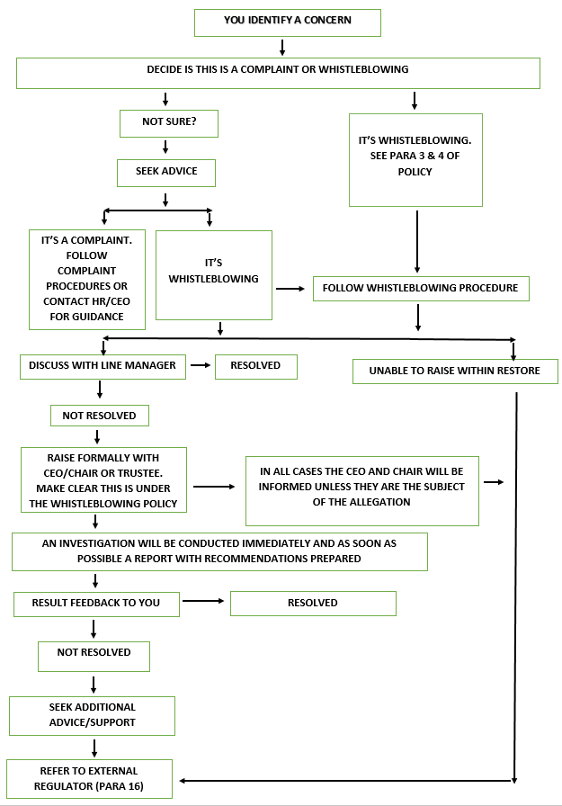
ANNEX 1: WHISTLEBLOWING FLOW CHART

